Software Requirements Specification
for
Smart Traffic Lights Simulation
Version 1.0 approved
Prepared by
Rabia Latif 20-SE-024
Abdullah Asif 20-SE-067
Samrin Fatima 20-SE-068

HITEC University Taxila Cantt
29 November,2023

Table of Contents
1. Introduction 1
1.1 Project Overview 1
1.2 Objectives and Goals 1
1.3 Purpose 1
1.4 Document Conventions 1
1.5 Intended Audience and Reading Suggestions 1
1.6 Product Scope 2
1.7 References 3
2. Overall Description 3
2.1 Product Perspective 3
2.2 Product Functions 4
2.3 User Classes and Characteristics 4
2.4 Operating Environment 5
2.5 Design and Implementation Constraints 5
2.6 User Documentation 6
2.7 Assumptions and Dependencies 6
3. External Interface Requirements 7
3.1 User Interfaces 7
3.2 Hardware Interfaces 7
3.2.1 Traffic Signal Interface 7
3.2.2 Emergency Vehicle Interface 8
3.3 Software Interfaces 8
3.3.1 User Interface (UI) 8
3.3.2 Database Interface 8
3.3.3 AI Algorithm Interface 9
3.4 Communications Interfaces 9
4. System Features 9
4.1 Real-Time Traffic Analysis 9
4.1.1 Description and Priority 9
4.1.2 Stimulus/Response Sequences 9
4.1.3 Functional Requirements 10
4.2 Adaptive Signal Control: 10
4.2.1 Description and Priority 10
4.2.2 Stimulus/Response Sequences 10
4.2.3 Functional Requirements 10
4.3 Emergency Vehicle Priority: 11
4.3.1 Description and Priority 11
4.3.2 Stimulus/Response Sequences 11
4.3.3 Functional Requirements 11
4.4 Traffic Pattern Prediction 11
4.4.1 Description and Priority 11
4.4.2 Stimulus/Response Sequences 12
4.4.3 Functional Requirements 12
4.5 Pedestrian Safety 12
4.5.1 Description and Priority 12
4.5.2 Stimulus/Response Sequences 12
4.5.3 Functional Requirements 13
5. Other Nonfunctional Requirements 13
5.1 Performance Requirements 13
5.2 Safety Requirements 14
5.3 Security Requirements 14
5.4 Software Quality Attributes 15
5.5 Business Rules 15
6. Other Requirements 16
7. Testing and Quality Assurance 17
7.1 Testing Requirements 17
7.2 Scope 17
7.3 Acceptance Criteria 18
7.4 Quality Assurance Plan 19
7.5 QA Schedule 19
7.6 Quality Control 19
8. Appendix A: Glossary 20
9. Appendix B: Analysis Models 20
10. Appendix C: To Be Determined List 20

Revision History
Name | Date | Reason For Changes | Version

Introduction
The Smart Traffic Light Simulation is a comprehensive system that uses cutting-edge algorithms and artificial intelligence (AI) to completely transform urban traffic management. The whole STLS, including its fundamental features, capacity for data integration, and performance requirements, is covered by this SRS. It solves the issues of urban traffic congestion, delays, and safety concerns by using artificial intelligence (AI) to automate the role of traffic wardens, optimize traffic flow, prioritize emergency response, and improve the overall commuter experience.

Project Overview
Urban traffic congestion is a pressing issue, causing delays, pollution, and fuel waste. To combat this, we propose an AI-driven Smart Traffic Light system simulation that adapts traffic signals in real-time, optimizing traffic flow and reducing congestion. Our objectives encompass AI algorithm development for automating tasks of traffic warden and traffic analysis, adaptive traffic signal control, and integration of an emergency response system. The system aims to prioritize emergency vehicles efficiently. Upon implementation, it is expected to significantly improve traffic flow in real urban settings, presenting an innovative solution to modern urban transportation challenges.

Objectives and Goals
Objectives
- Development of AI Algorithms: Develop robust AI algorithms capable of analyzing real-time traffic data, predicting traffic patterns, and identifying emergency vehicles.
- Adaptive Traffic Light Control: Implement a dynamic traffic light control system that can adjust signal timings in real-time based on AI predictions to optimize traffic flow.
- Emergency Response Integration: Integrate emergency response prioritization into the traffic management system, allowing emergency vehicles to pass through intersections swiftly during emergencies.
- Enhanced Traffic Flow: Improve traffic flow and reduce congestion at key intersections through the AI-driven traffic light control system.
- Reduced Commuter Waiting Times: Decrease waiting times for regular commuters at traffic signals, enhancing overall commute efficiency and satisfaction.
- Efficiency and Energy Conservation: Optimize signal timings to reduce unnecessary vehicle idling, contributing to energy conservation and environmental sustainability.
- Real-time Adaptation: Enable the system to adapt instantaneously to changing traffic conditions and emergency events to ensure optimal traffic management.
- Safety and Public Welfare: Prioritize public safety by ensuring the swift and efficient passage of emergency vehicles, potentially saving lives and minimizing property damage.
- Data-Driven Decision-Making: Collect and analyze real-time data to support data-driven decision-making for urban planning and traffic infrastructure improvements.
We collectively aim to create a practical, efficient, and safe solution that leverages AI to optimize urban traffic management and enhance emergency response, ultimately improving the quality of life in urban areas.
Goals
Our goal is
“Optimize traffic flow with AI algorithms, prioritize emergency vehicles for swift response, and reduce commuter wait times for a more efficient and safe urban commute. Additionally, focus on energy conservation through optimized signal timings and utilize real-time data for informed urban planning decisions.”

Purpose
The Smart Traffic Light Simulation is a comprehensive system that uses cutting-edge algorithms and artificial intelligence (AI) to completely transform urban traffic management. The whole STLS, including its fundamental features, capacity for data integration, and performance requirements, is covered by this SRS. It solves the issues of urban traffic congestion, delays, and safety concerns by using artificial intelligence (AI) to automate the role of traffic wardens, optimize traffic flow, prioritize emergency response, and improve the overall commuter experience.

Document Conventions
The document is prepared using Microsoft Word 2016 and has used the font type 'Times New Roman'. The fixed font size that has been used to type this document is 12pt with 1.5 line spacing. It has used the bold property to set the headings of the document. Use case scenario is written according to Alistair Cockburn’s template. UML diagrams have been created according to UML 2.0 standards. Standard IEEE template is the template used to organize the appearance of the document and its flow.

Intended Audience and Reading Suggestions
Intended Audience:
- Transportation Authorities and Departments: Officials responsible for urban infrastructure, traffic management, and city planning.
- Traffic Engineers and Planners: Professionals involved in traffic flow analysis, signal optimization, and urban mobility design.
- Technology and AI Enthusiasts: Individuals interested in the intersection of artificial intelligence, smart systems, and urban transportation.
- Emergency Response Agencies: Personnel involved in emergency services interested in systems prioritizing emergency vehicle passage.
Reading Suggestions:
[1]. "Traffic Flow: Fundamentals, Measures, and Control" by Moshe Ben-Akiva and Hani S. Mahmassani: Explores traffic flow theories and control mechanisms essential for traffic engineers and planners.
[2]. "Smart Cities: Big Data, Civic Hackers, and the Quest for a New Utopia" by Anthony M. Townsend:Discusses the role of technology in shaping modern cities, including traffic management and smart infrastructure.
[3]. "Artificial Intelligence: A Guide for Thinking Humans" by Melanie Mitchell:Provides insights into AI fundamentals and its potential applications in various fields, including transportation systems.
[4]. Intelligent Transportation Systems: Functional Design for Effective Traffic Management" by Asad J. Khattak and Sachin S. Sharma: Focuses on the design and implementation of intelligent transportation systems, including traffic control.
[5]. Industry Reports and Journals: Explore publications from organizations like the Institute of Transportation Engineers (ITE) or Intelligent Transportation Society of America (ITSA) for the latest advancements and case studies in smart traffic management.

Product Scope
Targeting the growing issues of urban traffic congestion, delays, and safety concerns, the Smart Traffic Light Simulation System (STLSS) is a comprehensive solution designed to revolutionize urban traffic management utilizing artificial intelligence (AI) and cutting-edge algorithms. The system uses AI to improve commuter experience, prioritize emergency response, and optimize traffic flow. Enabling real-time adaptation to changing conditions, prioritizing public safety, integrating emergency response prioritization, improving traffic flow, cutting down on commuter wait times, optimizing signal timings for efficiency and energy conservation, and supporting data-driven decision-making are some of the main goals. Other key objectives include developing robust AI algorithms for real-time traffic analysis and putting in place an adaptive traffic light control system.

References
[1] IEEE SRS Template

[1] Zia, S. S., Naseem, M., Mala, I., TAHIR, M., MUGHAL, T., & MUBEEN, T. (2018). Smart Traffic Light System by Using Artificial Intelligence. Sindh University Research Journal-SURJ (Science Series), 50(4), 639-646.
[2] Cruz-Piris, L., Rivera, D., Fernandez, S., & Marsa-Maestre, I. (2018). Optimized sensor network and multi-agent decision support for smart traffic light management. Sensors, 18(2), 435.
[3] Gandhi, M. M., Solanki, D. S., Daptardar, R. S., & Baloorkar, N. S. (2020, December). Smart control of traffic light using artificial intelligence. In 2020 5th IEEE international conference on recent advances and innovations in engineering (ICRAIE) (pp. 1-6). IEEE.
[4] https://www.cmu.edu/epp/people/faculty/course-reports/SURTRAC%20Final%20Report.pdf
[5] https://dot.ca.gov/-/media/dot-media/programs/traffic-operations/documents/mobility/traffic-signal-business-plan-2015-a11y.pdf
[6] https://youtube.com/watch?v=OssY5pzOyo0

Overall Description

Product Perspective
The Smart Traffic Light Simulation System is designed as a standalone product aimed at revolutionizing traffic management. It is not a replacement for existing systems but rather a new, innovative solution to address the challenges of urban traffic. This system operates independently, providing advanced features such as real-time traffic data analysis, predictive modeling, and emergency vehicle prioritization. While it is a self-contained product, its success is contingent on seamless integration with external components and services. The system relies on external services like map integration for accurate incident location data, weather data for precise predictions, and mobile app platforms for user interactions. The dependencies on these external factors are crucial to the overall functionality of the system. The Smart Traffic Light Simulation System can be visualized as a standalone entity with external connections, creating a symbiotic relationship with various services to enhance its capabilities. A diagram illustrating these connections and interfaces would showcase the system's major components, highlighting its independence as well as its reliance on external interfaces for optimal performance.

Product Functions
The Smart Traffic Light Simulation System is made to carry out essential tasks for effective traffic control. It continuously collects and processes real-time traffic data from multiple sources, analyzing patterns and trends in traffic flow with the help of cutting-edge AI algorithms. By using image processing or sensor data to identify emergency vehicles, the system can prioritize their placement. In order to maximize traffic flow, dynamic signal timing optimization modifies traffic signals in real-time based on AI predictions and the presence of emergency vehicles. With the help of an easy-to-use interface, users can control traffic signals and system settings. In addition, the system produces extensive performance metrics that offer useful information for efficient traffic management and planning. These metrics include historical and real-time data on waiting periods, average travel times, and congestion levels.

User Classes and Characteristics
User classes have been mentioned in table below priority high to low has been
allocated based on their frequency of usage, Technical expertise, Security Privilege
levels and Educational level. The user classes for the product that simulates smart traffic lights can be divided into high and low priority groups as follows:
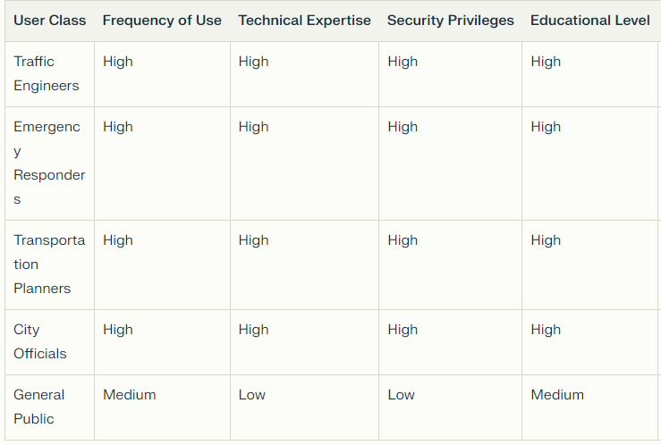
Highest Priority:
- Planners and Engineers of Traffic
- Policymakers and City Officials
- Administrators of Systems
Lowest Concern:
- The Whole Public
The smart traffic light simulation system's efficient management, optimization, and decision-making depend on the high priority user classes. They directly affect how the system functions and is configured, as well as the rules that regulate how it is used. However, even though the general public benefits from the system, they do not directly engage with its features and have less influence over its administration and operation.

Operating Environment
Software Requirements:
- Front End – Anaconda IDE,Jupiter Notebook
- Backend – SQL
- Language – Python 3.8
Hardware Requirements
- Hard Disk: Greater than 500 GB
- RAM: Greater than 4 GB
- Processor: I3 and Above

Design and Implementation Constraints
The constraints pertaining to the design and implementation of the smart traffic light simulation system may restrict the developers' options. These include hardware constraints for the gathering and processing of real-time traffic data, such as particular timing and memory requirements. Regulations pertaining to safety and traffic management must also be complied with by the system, especially those that deal with emergency vehicle prioritization and detection. Furthermore, the system might have to interface with other applications, which would call for the use of particular tools, technologies, and databases. Security is the first priority, and sensitive data must be protected and unauthorized access must be prevented by the system's design. Furthermore, it is imperative to follow design guidelines and programming standards.

User Documentation
The user documentation for the smart traffic light simulation system will include the following components:
1. User Manual: To assist users with the installation, configuration, and use of the system, a thorough user manual will be supplied. It will go over all of the system's features and functionalities and offer best practices and troubleshooting advice.
2. Online Help: To offer users context-sensitive support, an online help system will be integrated into the software interface. This will make it possible for users to access instructions and pertinent information quickly while utilizing the system.
3. Tutorials: To assist users in becoming proficient with the system, a number of tutorials will be made available. These tutorials will include examples and step-by-step instructions covering common tasks and scenarios.
The user documentation will be delivered in digital format, and will adhere to standard documentation delivery formats and best practices. It will be accessible from the software interface, as well as from the developer's website or knowledge base. The documentation will be regularly updated to ensure that it remains accurate and relevant.
Citations:
[1] https://www.mdpi.com/1424-8220/23/11/5028
[2] https://is.ifmo.ru/download/svetofor_doc_eng.pdf
[3]https://www.researchgate.net/publication/338647535_Design_and_Implementation_of_a_Smart_Traffic_Signal_Control_System_for_Smart_City_Applications
[4]https://www.researchgate.net/publication/341190948_Design_and_Implementation_of_a_Smart_Traffic_Light_Management_System_Controlled_Wirelessly_by_Arduino
[5] https://github.com/MarmerMax/Smart-Traffic-Light

Assumptions and Dependencies
The Smart Traffic Lights Simulation System is heavily reliant on assumptions, and a number of important variables are taken into account. First off, the precision of predictions and traffic light control could be jeopardized by discrepancies, so the system relies on the accuracy and dependability of real-time traffic data. Second, the Emergency Vehicle Priority feature assumes that efficient coordination with outside emergency response systems is maintained, which in turn depends on effective coordination. Furthermore, consistent network connectivity is necessary for user interactions, and any interruptions in this connectivity may make it more difficult for users to access essential features. Dependencies, on the other hand, draw attention to the dependence on outside resources and services. For accurate location data, the system depends on an external map integration service; modifications or disruptions.

External Interface Requirements

User Interfaces
Graphical user interface must be implemented using Neilsen’s 10 heuristic rules which are listed below:
● Visibility of system status
● Match between system and the real world
● User control and freedom
● Consistency and standards
● Error Prevention
● Recognition rather than recall
● Flexibility and efficiency of use
● Aesthetic and minimalist design
● Help users recognize, diagnose, and recover from errors.
● Help and documentation

Hardware Interfaces
- Type: Traffic sensors and cameras
- Purpose: Collect real-time traffic data, including vehicle positions, speeds, and directions.
- Data Interactions:
  - Incoming: Traffic data from sensors and cameras.
  - Outgoing: Acknowledgement messages and configuration updates.

Traffic Signal Interface
- Type: Traffic signal controllers
- Purpose: Receive traffic signal control commands and adjust signal timings accordingly.
- Data Interactions:
  - Incoming: Traffic signal control commands from the STLSS.
  - Outgoing: Status updates and error messages from traffic signal controllers.

Emergency Vehicle Interface
- Type: Emergency vehicle communication systems
- Purpose: Receive emergency vehicle location information and prioritize emergency vehicle passage at intersections.
- Data Interactions:
  - Incoming: Emergency vehicle location information from emergency vehicle communication systems or onboard sensors.
  - Outgoing: Acknowledgement messages and signal preemption commands.

Software Interfaces

User Interface (UI)
- Type: Graphical User Interface (GUI)
- Purpose: Provide a user-friendly interface for traffic management personnel to monitor traffic conditions, control traffic signals, and manage system settings.
- Data Interactions:
  - Incoming: Traffic data from sensors and cameras, user inputs, and system status updates.
  - Outgoing: Traffic signal control commands, system configuration updates, and notifications to users.

Database Interface
- Type: Relational Database Management System (RDBMS)
- Purpose: Store and manage traffic data, system configurations, and user information.
- Data Interactions:
  - Incoming: Traffic data from real-time feeds, user interactions, and system logs.
  - Outgoing: Traffic data for analysis, traffic signal control parameters, and user authentication credentials.
- Communication Protocol: SQL

AI Algorithm Interface
- Type: AI framework or library, such as TensorFlow or PyTorch
- Purpose: Provide AI algorithms for real-time traffic analysis, pattern prediction, and emergency vehicle identification.
- Data Interactions:
  - Incoming: Real-time traffic data from sensors and cameras.
  - Outgoing: Traffic pattern predictions, emergency vehicle locations, and recommendations for traffic signal adjustments.
- Communication Protocol: Function calls, data serialization formats

Communications Interfaces
Communication interface will be:
- Cloud
- Database
- AI Alogrithm
- Data repositories
- Output screen

System Features

Real-Time Traffic Analysis
The system collects and analyzes real-time traffic data to make informed decisions about traffic signal timings.

Description and Priority
The "Real-Time Traffic Analysis" feature involves the continuous collection and analysis of real-time traffic data to make informed decisions about traffic signal timings. This is of high priority as it forms the core functionality of the Smart Traffic Light Simulation System, influencing the system's ability to dynamically optimize traffic flow.

Stimulus/Response Sequences
Stimulus: The system receives real-time traffic data from various sources.
Response: The system processes the data and determines optimal traffic signal timings.

Functional Requirements
REQ-1: The system must establish a continuous connection to traffic sensors, cameras, and vehicle-to-infrastructure communication for real-time data acquisition.
REQ-2: AI algorithms must analyze the incoming traffic data to identify patterns, trends, and anomalies.
REQ-3: The system should dynamically adjust traffic signal timings based on the real-time analysis to optimize traffic flow.
REQ-4: In case of communication errors or data unavailability, the system should provide a notification or use default settings.
REQ-5: The system must ensure that the real-time traffic analysis is updated at frequent intervals to adapt to changing traffic conditions.
REQ-6: There should be a logging mechanism to record the real-time traffic data and system responses for future analysis and audit purposes.

These requirements ensure that the system can effectively collect, analyze, and respond to real-time traffic data, meeting the high-priority need for dynamic traffic signal optimization.

Adaptive Signal Control:
Traffic lights adjust their timings dynamically to optimize regular traffic flow based on current conditions.

Description and Priority
The Adaptive Signal Control feature involves the dynamic adjustment of traffic signal timings to optimize regular traffic flow in response to current conditions. This is considered a High priority feature as it directly contributes to the system's core objective of enhancing traffic efficiency and reducing congestion.

Stimulus/Response Sequences
Stimulus: User actions include monitoring traffic conditions, initiating adjustments through the control interface.
Response: The system dynamically modifies signal timings, optimizing traffic flow in real-time based on the observed conditions.

Functional Requirements
REQ-1: Traffic Condition Monitoring: The system must continuously monitor real-time traffic conditions using data from sensors, cameras, and V2I communication.
REQ-2: Dynamic Signal Adjustment: The system should dynamically adjust signal timings based on AI predictions, real-time traffic patterns, and emergency vehicle presence.
REQ-3: User Interface Integration: Provide an intuitive interface for users to observe traffic conditions and manually initiate adaptive signal adjustments.
REQ-4: Real-time Feedback: The system should provide real-time feedback to users on the status and effectiveness of adaptive signal adjustments.
REQ-5: Error Handling: Implement error handling mechanisms to address potential issues in signal adjustment processes and ensure system stability.
REQ-6: Logging and Reporting: Log and report adaptive signal control activities, including adjustments made, traffic conditions, and system responses, for performance analysis and system improvement.

These requirements ensure the effective implementation of the Adaptive Signal Control feature, promoting efficient traffic flow management in the Smart Traffic Light Simulation System.

Emergency Vehicle Priority:
An integrated emergency response system recognizes and prioritizes the passage of emergency vehicles by altering traffic signals.

Description and Priority
The Emergency Vehicle Priority feature enables the smart traffic light simulation system to integrate with an emergency response system, recognizing and prioritizing the passage of emergency vehicles by dynamically altering traffic signals. This functionality is of high priority due to its critical role in enhancing public safety and minimizing response times during emergencies.

Stimulus/Response Sequences
Stimulus: An emergency vehicle approaches an intersection.
Response: The system recognizes the emergency vehicle through integrated sensors or communication and initiates the priority sequence.

Functional Requirements
REQ-1: The system must integrate with sensors or image processing capabilities to accurately detect the presence of emergency vehicles.
REQ-2: Upon detection of an emergency vehicle, the system should promptly communicate with the traffic signal control system.
REQ-3: The traffic signal control system must dynamically adjust signal timings to provide a green light for the approaching emergency vehicle, minimizing intersection delays.
REQ-4: In the event of conflicting signals, the system should prioritize emergency vehicle passage, ensuring the safety of both the emergency response team and other commuters.
REQ-5: Users or authorized emergency personnel should have a straightforward interface to activate the emergency vehicle priority feature.
REQ-6: The system must log and record instances of emergency vehicle prioritization for analysis and reporting purposes.

These requirements collectively ensure the effective implementation of the Emergency Vehicle Priority feature, aligning with its high priority status for the overall Smart Traffic Light Simulation System.

Traffic Pattern Prediction
AI algorithms predict traffic patterns to proactively adjust signal timings and minimize congestion.

Description and Priority
Traffic Pattern Prediction is a critical feature with a High priority in the Smart Traffic Light Simulation System. This functionality utilizes AI algorithms to foresee traffic patterns, allowing the system to proactively adjust signal timings and minimize congestion. The high priority reflects its significant impact on optimizing traffic flow and enhancing overall system efficiency.

Stimulus/Response Sequences
- Stimulus: The system continuously receives real-time traffic data.
Response: AI algorithms analyze the data, predicting upcoming traffic patterns.

- Stimulus: An identified trend indicates potential congestion.
Response: The system dynamically adjusts traffic signal timings to alleviate congestion.

Functional Requirements
REQ-1: Traffic Pattern Prediction Algorithm
The system must employ AI algorithms capable of predicting traffic patterns based on real-time data.
REQ-2: Proactive Signal Timing Adjustment
The system should proactively adjust traffic signal timings based on predicted traffic patterns to minimize congestion.
REQ-3: Real-time Data Integration
The system must continuously integrate and process real-time traffic data from various sources.
REQ-4: Trend Analysis
The system should conduct trend analysis on the predicted traffic patterns to identify potential congestion points.
REQ-5: Dynamic Signal Control
The system must dynamically control traffic signals based on the predicted patterns to optimize traffic flow.
REQ-6: Error Handling
In case of errors or inaccuracies in predicting traffic patterns, the system should revert to default signal timings and generate appropriate error notifications for review.

These requirements ensure that the Traffic Pattern Prediction feature operates seamlessly, providing the system with the ability to anticipate and respond effectively to changing traffic conditions.

Pedestrian Safety
The system incorporates safety measures for pedestrians by controlling crosswalk signals and monitoring pedestrian traffic.

Description and Priority
The Pedestrian Safety feature is of high priority in the Smart Traffic Light Simulation System. Ensuring the safety of pedestrians by controlling crosswalk signals and monitoring pedestrian traffic is critical for the overall effectiveness and responsibility of the system.

Stimulus/Response Sequences
- User Activates Crosswalk Signal:
Stimulus: User presses the crosswalk button.
Response: The system activates the crosswalk signal, indicating a safe time for pedestrians to cross.

- Pedestrian Traffic Monitoring:
Stimulus: Pedestrians enter the crosswalk.
Response: The system monitors pedestrian traffic and adjusts signal timings accordingly.

Functional Requirements
REQ-1: Crosswalk Signal Activation:
The system shall activate the crosswalk signal promptly in response to user input.
The system shall provide visual and auditory signals to indicate the safe crossing period.
REQ-2: Pedestrian Traffic Monitoring:
The system shall utilize sensors or cameras to monitor pedestrian traffic at crosswalks.
It shall dynamically adjust signal timings based on real-time pedestrian movement, prioritizing their safety.
REQ-3: Emergency Override for Pedestrian Safety:
The system shall allow emergency vehicles to trigger an override, temporarily halting pedestrian crossings for enhanced safety.
REQ-4: Error Handling:
In case of a malfunction or sensor failure, the system shall default to a safe mode, providing continuous signals for pedestrian safety.
The system shall log and report any technical issues for prompt maintenance.

These requirements ensure that the Pedestrian Safety feature not only responds effectively to user and system stimuli but also incorporates fail-safes and error handling mechanisms for enhanced reliability.

Use Case Description
Use Case#01:
UserElement | Description
Use Case ID | UC001
Use Case Name | AI-driven Signal Timing
Actor | AI Traffic Control Module
Description | This use case involves an AI-driven system that dynamically adjusts traffic signal timings based on real-time traffic conditions to optimize traffic flow and reduce congestion.
Precondition | Real-time traffic data is available.  AI algorithms are configured and ready to use.
Postcondition | Traffic lights are timed to optimize traffic flow.  Congestion is reduced.  Waiting times at traffic signals are reduced.
Normal Flow | 1. The smart traffic light system receives real-time traffic data from sensors and cameras.  2. The system feeds the data into AI algorithms to predict future traffic conditions.  3. The system uses the predictions to determine the optimal signal timings for each intersection.  4. The system sends signals to the traffic lights to adjust their timings.
Alternate Flows | Traffic management personnel have the option to manually override AI-generated signal timings in case of emergency or special events.
Exception Paths | If there's an issue with the accuracy or reliability of incoming data, the system relies on historical patterns or default settings until accurate data is restored.
Inclusion | The system integrates with emergency service vehicles to provide priority green lights for faster response times.
Special Requirements | The system should adapt to varying traffic conditions throughout the day and accommodate changes in traffic patterns.
Assumptions | Assumes the availability of reliable and accurate real-time traffic data from various sources.  Assumes the traffic signal infrastructure is capable of being dynamically controlled based on the AI-generated recommendations.
Frequency of Use | High during real time traffic analysis

Use Case#02:
Element | Description
Use Case ID | UC002
Use Case Name | Real Time Traffic analysis
Actor | Traffic Analyst
Description | The objective of this use case is to offer insights into traffic patterns, congestion, and the best routes by analyzing traffic data in real-time that has been collected from various sources.
Precondition | Traffic data from sensors and cameras is available
Postcondition | The system has an up-to-date understanding of traffic conditions.  The system can use this information to make informed decisions about signal timing
Normal Flow | - Receive Data: A variety of sources, including sensors, cameras, and GPS, are used to gather traffic data.  - Data processing: Relevant information such as traffic volume, speed, and congestion levels are extracted from raw data.  - Analysis: To determine traffic patterns and congested areas, analyzed data is interpreted.  - Visualization: To promote understanding, results are displayed using maps or graphical representations.  - Making Decisions: Analysts use the insights to recommend the best routes.
Alternate Flows | If any data sources fail to provide information, the system flags the issue and continues with available data.
Exception Paths | If there are errors in data processing or analysis, the system logs the issue and notifies the administrator.
Inclusion | The analyzed data can be integrated with navigation apps or systems to provide real-time route recommendations.
Special Requirements | It should be scalable to handle increasing data volumes during peak traffic times.
Assumptions | Assumed that the data received from sources is accurate and timely.
Frequency of Use | High, as this is a core function because of real time analysis of data.

Use Case#03:
Element | Description
Use Case ID | UC003
Use Case Name | Emergency Vehicle Prioritization
Actor | Emergency Vehicles
Description | This use case involves an AI-driven system that prioritizes emergency vehicles by dynamically controlling traffic lights to enable faster passage through intersections.
Precondition | The AI algorithm for traffic light control is operational and connected to sensors or cameras to detect emergency vehicles.
Postcondition | Emergency vehicle passes through the intersection quickly and safely.  Response time is minimized.
Basic Flow | 1. The emergency vehicle sends a signal to the smart traffic light system.  2. The system detects the emergency vehicle and its location.  3. The system prioritizes the emergency vehicle and adjusts signal timings to allow it to pass
Alternative Flows | In cases where multiple emergency vehicles approach from different directions, the AI system prioritizes their passage while managing conflicting paths.
Exception Paths | In the event of AI system failure or communication breakdown, traffic lights default to standard operation, and emergency vehicles might face regular traffic conditions.
Special Requirements | Secure and reliable communication protocols between emergency vehicles and the traffic management system to prevent misuse or interference.
Assumptions | Assumes the AI algorithm accurately determines the priority of emergency vehicles based on predefined criteria..

Element | Description
Use Case ID | UC004
Use Case Name | Adaptive Traffic Control
Actor | AI Controller
Description | This use case involves implementing AI-driven traffic control systems that dynamically adjust traffic signal timings based on real-time traffic conditions to optimize traffic flow.
Precondition | Traffic conditions change, such as accidents or road closures.
Postcondition | Traffic flow is maintained despite changes in conditions.  Congestion is minimized..
Basic Flow | 1. The smart traffic light system detects a change in traffic conditions.  2. The system analyzes the change and determines the best course of action.  3. The system adjusts signal timings and routes traffic to minimize disruption.
Alternative Flows | The system recognizes emergency vehicle signals and prioritizes their passage by dynamically adjusting nearby traffic signals to provide a clear path.
Exception Paths | If there's a failure in data collection or processing, the system defaults to manual control until the issue is resolved.
Special Requirements | The system collaborates with emergency service systems to facilitate smooth passage during emergencies by clearing traffic.
Assumptions | Capable of adapting to varying traffic patterns during different times of the day or special events.

Element | Description
Use Case ID | UC005
Use Case Name | Performance monitoring
Actor | Traffic Lights
Description | This use case involves using AI-based algorithms for real-time performance monitoring of traffic lights to optimize traffic flow.
Precondition | Performance data is collected.  Transportation authorities have access to performance data.
Postcondition | Transportation authorities are aware of the system's performance.  Transportation authorities can make informed decisions about improvements to the system.
Basic Flow | 1. The smart traffic light system collects data on its performance.  2. The system analyzes the data to identify areas for improvement.  3. The system provides feedback to transportation authorities on its performance.
Alternative Flows | Traffic management personnel can manually override AI-generated signal timings in case of emergency situations.
Exception Paths | If the AI algorithm fails to generate optimized plans, the system reverts to default signal timing or manual control until the issue is resolved.
Special Requirements | The AI system should continuously learn from real-time traffic data to improve its optimization strategies over time.
Assumptions | The AI system should continuously learn from real-time traffic data to improve its optimization strategies over time.

Other Nonfunctional Requirements

Performance Requirements

- Response Time: The system shall respond to user requests and real-time traffic data within 1 second to ensure seamless operation and effective traffic management.
- Scalability: The system shall be scalable to accommodate increasing traffic volumes and data loads without compromising performance. It should be able to handle traffic spikes and adapt to changing traffic patterns effectively.
- Throughput: The system shall be able to process and analyze large amounts of real-time traffic data efficiently, ensuring that traffic patterns and trends are identified promptly.

Safety Requirements

Emergency Response Prioritization:
- Emergency Vehicle Detection: The system shall accurately and timely detect emergency vehicles approaching intersections using sensors, cameras, or other means.
- Signal Preemption: The system shall prioritize emergency vehicles by preempting traffic signals, allowing them to swiftly pass through intersections without delay.
- Real-time Coordination: The system shall maintain real-time coordination with emergency services to ensure that signal preemption is activated only for authorized vehicles and during critical situations.
Traffic Flow Optimization:
- Adaptive Signal Timing: The system shall dynamically adjust traffic signal timings based on real-time traffic conditions and AI predictions to optimize traffic flow and reduce congestion.
- Intersection Coordination: The system shall coordinate traffic signals across multiple intersections to minimize delays and improve overall traffic flow.
- Predictive Analytics: The system shall utilize predictive analytics to anticipate future traffic patterns and adjust signal timings proactively to prevent congestion and improve traffic flow.
Public Safety:
- Infrastructure Safety: The system shall adhere to all safety standards and regulations for traffic infrastructure, ensuring that traffic signals and other components are properly installed and maintained.
- Data Privacy: The system shall protect sensitive traffic data, including vehicle locations and travel patterns, to prevent unauthorized access and misuse.
- Incident Detection: The system shall monitor traffic conditions for potential incidents, such as accidents or road closures, and alert traffic management personnel promptly.
Reliability and Fault Tolerance:
- Hardware Redundancy: Critical hardware components, such as sensors and communication devices, shall have redundancy to minimize the impact of component failures.
- System Backup: The system shall maintain regular backups of traffic data and system configurations to ensure data integrity and facilitate recovery from failures.
- Continuous Monitoring: The system shall continuously monitor its performance and health, alerting traffic management personnel to potential issues or malfunctions promptly.

Security Requirements

- Data Security: The system shall implement robust security measures to protect sensitive traffic data, including user information, traffic patterns, and emergency vehicle locations.
- Access Control: The system shall enforce strict access control mechanisms, ensuring that only authorized users can access and modify system settings and data.
- Threat Mitigation: The system shall be equipped with security solutions to mitigate cyberattacks, such as data encryption, intrusion detection, and access control mechanisms.

Software Quality Attributes

- Efficiency: The STLSS shall handle traffic management tasks quickly and effectively, minimizing resource utilization and user effort.
- Maintainability: The STLSS shall be designed in a modular, well-documented, and easily diagnosable manner to facilitate future modifications and updates.
- Availability: The STLSS shall operate continuously and reliably, minimizing downtime and disruptions to traffic management operations.
- Reliability: The STLSS shall deliver consistent and predictable performance, handling unexpected events and errors gracefully without compromising its core functionality.
- Usability: The STLSS shall provide an intuitive and user-friendly interface that is easy to learn and operate for traffic management personnel.
- Portability: The STLSS shall be portable across different hardware and software platforms, allowing it to be deployed in various environments without significant modifications.
- Testability: The STLSS shall be designed to be easily tested, with well-defined test cases and procedures to ensure its functionality and quality.
- Compliance: The STLSS shall comply with all applicable regulations and standards related to traffic management systems, data privacy, and cybersecurity.
- Cost-Effectiveness: The STLSS shall be cost-effective to develop, deploy, and maintain, balancing its functionality and performance with its overall cost.
- User Satisfaction: The STLSS shall meet the needs and expectations of its users, providing a satisfactory experience for traffic management personnel.
- Environmental Impact: The STLSS shall be designed to minimize its environmental impact, optimizing energy consumption and reducing its carbon footprint.

Business Rules
For both drivers and other interest groups, smart traffic light systems may offer a number of advantages. Reducing the amount of time cars sit idle on the road while promoting the best possible use of road transportation is one of the main goals of these systems[1]. As a result, there may be less air pollution, such as particulate matter and greenhouse gas emissions, and traffic congestion. Therefore, there may be an incentive for cities to invest in smart traffic light technology if they are not in compliance with state and federal environmental regulations regarding particulate matter[1]. Additionally, by encouraging active transportation and lowering pollution in neighborhoods, smart traffic signal systems can improve community health. By expanding and enhancing the availability of accessible and safe active transportation options.

Other Requirements
Database Requirements:
The STLSS shall utilize a relational database management system (RDBMS) to store and manage traffic data, system configurations, and user information. The database shall be designed to handle high volumes of real-time data efficiently and support complex queries for traffic analysis and decision-making.
Internationalization Requirements:
The STLSS shall support multiple languages to accommodate users from diverse regions and facilitate international deployments. The system's interface, user manuals, and documentation shall be translated into relevant languages, and the system shall be able to handle character sets and date formats from different locales.
Legal Requirements:
The STLSS shall comply with all applicable laws and regulations related to data privacy, cybersecurity, and traffic management. This includes data protection regulations such as the General Data Protection Regulation (GDPR) and the California Consumer Privacy Act (CCPA), as well as cybersecurity standards and traffic management guidelines specific to the region of deployment.
Reuse Objectives:
The STLSS shall be designed with reusability in mind, utilizing modular components and open-source libraries where possible. This will facilitate future enhancements, integration with existing traffic management systems, and adaptation to specific customer requirements.
Non-Functional Testing Requirements:
In addition to functional testing, the STLSS shall undergo rigorous non-functional testing to ensure its performance, availability, reliability, security, and usability. This includes load testing, stress testing, performance benchmarking, penetration testing, security audits, and usability testing with diverse user groups.
Continuous Integration and Continuous Delivery (CI/CD):
The STLSS development process shall implement a CI/CD pipeline to automate the build, test, and deployment of software updates. This will streamline the development process, ensure rapid delivery of new features and bug fixes, and minimize the risk of introducing regressions.
Monitoring and Logging:
The STLSS shall implement comprehensive monitoring and logging capabilities to track system performance, identify potential issues, and facilitate root-cause analysis. This includes monitoring traffic data, system resource utilization, error logs, and user interactions.
Documentation and Training:
Comprehensive documentation shall be provided for the STLSS, including system architecture, user manuals, maintenance guidelines, and training materials. Training sessions shall be conducted for traffic management personnel to ensure they can effectively utilize the system's features and capabilities.

Testing and Quality Assurance

Testing Requirements
Establish a comprehensive testing strategy to ensure that all features of the Smart Traffic Lights Simulation System meet the predefined functional and non-functional requirements.

Scope
- Functional Testing:
Ensuring that each feature in the Smart Traffic Lights Simulation System works as per the specified requirements. For example, verifying that real-time traffic data acquisition, emergency vehicle detection, and signal timing optimization operate correctly.

- Usability Testing:
Checking that the system is easy to use and understand, focusing on user-friendliness. This includes assessing the interface for simplicity and making sure it is accessible for all users, including children who might interact with the system.

- Performance Testing:
Validating the system's responsiveness, stability, and scalability under various conditions. This involves testing how well the system performs during peak traffic hours, emergency situations, or when handling a significant volume of data.

- Security Testing:
Confirming that user data is securely handled and the application is safeguarded against potential vulnerabilities. This ensures that sensitive information is protected, and the system is resilient against potential cyber threats.

- Compliance Testing:
Verifying that the Smart Traffic Lights Simulation System adheres to all regulatory requirements, especially those related to children's online privacy and data protection. This ensures that the system complies with legal standards and safeguards user privacy, especially in contexts involving minors.

Acceptance Criteria
Criteria

1. Resolution of Critical Bugs:
All critical bugs identified during testing phases must be resolved before release.

2. Fulfillment of Functional Requirements:
The system must fulfill all functional requirements as outlined in the SRS.

3. Application Stability:
The application should not crash during typical user interactions and must handle errors gracefully.

4. Performance Benchmarks:
Performance benchmarks, including load times and response times, must be met or exceeded.

5. Positive User Experience:
Feedback from usability testing sessions must reflect a positive user experience.

Conditions

1. Acceptance Testing Environment: Acceptance testing will be conducted in an environment that mirrors the production setup.

2. Usability Testing Participants:
Both regular commuters and emergency service personnel will be part of usability testing to gather comprehensive feedback.

3. Security Testing Best Practices:
Security testing results must show that the application adheres to best practices for data encryption and user authentication.

Quality Assurance Plan
The quality assurance (QA) plan for Smart Traffic Lights Simulation includes the following key components:

  - Quality Goals: Establish clear, measurable quality goals aligned with user expectations and business objectives.
  - Quality Metrics: Define metrics for assessing the quality of the system, including defect densities, test coverage, and user satisfaction ratings.
  - QA Processes: Develop QA processes that encompass all stages of the software development lifecycle, from requirements analysis to post-release support.
  - Testing Tools and Environments: Identify and set up testing tools and environments needed to simulate real-world usage scenarios.
  - Risk Management: Implement a risk management strategy to identify potential quality risks early in the development process and plan for mitigation.
  - Documentation: Ensure all testing activities are thoroughly documented, including test plans, test cases, and test results.
  - Continuous Improvement: Use feedback from testing phases to continuously improve the system, focusing on areas that directly impact user satisfaction and engagement.

QA Schedule
A detailed QA schedule will be integrated with the overall project timeline, ensuring sufficient time is allocated for thorough testing and quality control.

Quality Control
The final quality control will be conducted before release, ensuring that the system meets all acceptance criteria.

Test Cases

AI-driven Signal Timing

Test case id | Test case objective | Pre requisite | Steps | Input data | Expected output | Actual output | Status
TC_01 | To verify the system's ability to adjust signal timing based on real-time traffic flow. | Traffic monitoring sensors are operational. | - Simulate heavy traffic conditions at a specific intersection.  - Ensure that the AI-driven system receives and processes real-time traffic data.  - Monitor the traffic light control system's response in adjusting signal timing to alleviate congestion. | Simulated heavy traffic flow data at the intersection. | The traffic light system should optimize signal timing to reduce congestion, allowing smoother traffic flow within a reasonable time frame.
TC_02 | To validate the system's response in emergency vehicle prioritization. | An emergency vehicle is detected by the system. | - Trigger an emergency vehicle signal within the system.  - Monitor how the traffic light system prioritizes the emergency vehicle's passage through the intersection. | Signal indicating the presence of an emergency vehicle. | The traffic light system should promptly adjust signals to provide a clear path for the emergency vehicle while ensuring the safety of other vehicles and pedestrians.
TC_03 | To test the system's adaptability to varying traffic patterns throughout the day. | Traffic data for different time frames is available for analysis. | - Provide the system with traffic data for different time periods (morning rush hour, mid-day, evening rush hour).  - Analyze how the system adjusts signal timings based on these varying traffic patterns. | Traffic flow data for different time frames. | The traffic light system should dynamically adjust signal timings to optimize traffic flow during each time frame, considering peak and off-peak traffic hours.

Real time traffic analysis

Test case id | Test case objective | Pre requisite | Steps | Input data | Expected output | Actual output | Status
TC_01 | To verify if the smart traffic light system can detect real-time traffic conditions and adjust signal timings accordingly. | The smart traffic light system is  Operational and connected to the traffic monitoring sensors. | - Simulate high traffic flow in the designated area.  - Observe the system's response time to the increased traffic.  - Check the signal timings adjustment based on the traffic data. | Simulated high traffic flow with sensor-generated data. | The traffic lights should adjust their timings to accommodate the increased traffic, allowing smoother traffic flow.
TC_02 | To validate the accuracy of the smart traffic light system in identifying traffic patterns. | The system should have historical traffic data for the specific area under consideration. | - Input historical traffic data covering various scenarios (e.g., rush hour, off-peak hours, accidents).  - Analyze the system's identification of traffic patterns and its response. | Historical traffic data representing different traffic scenarios. | The system accurately identifies and responds to different traffic patterns, optimizing signal timings accordingly.
TC_03 | To ensure the system maintains functionality during unexpected events or sensor failures. | The system should have redundancy measures and fail-safe mechanisms in place. | - Introduce a simulated sensor failure or unexpected traffic event (e.g., sudden road closure).  - Monitor the system's response and its ability to adapt to the situation. | Simulated sensor failure or unexpected traffic event data. | The system should respond by adapting signal timings using alternative data sources or predefined fail-safe mechanisms.

Emergency vehicle prioritization
Test case id | Test case objective | Pre requisite | Steps | Input data | Expected output | Actual output | Status
TC_01 | To verify the system's ability to detect an approaching emergency vehicle and prioritize traffic lights accordingly. | The system is operational and configured with emergency vehicle detection sensors. | - Simulate an approaching emergency vehicle within the system's detection range.  - Observe the traffic light response and change sequence. | Simulated emergency vehicle signal triggering the system. | The traffic light in the emergency vehicle's direction switches to green while other lights turn red to clear the path.
TC_02 | To test the system's reaction during heavy traffic conditions when an emergency vehicle approaches. | The system is operational, and there is heavy traffic in the environment. | - Simulate heavy traffic conditions.  - Trigger the emergency vehicle signal and observe the system's response. | Simulated heavy traffic scenario with an approaching emergency vehicle signal. | Traffic lights adapt to prioritize the emergency vehicle's path despite heavy traffic, allowing it to move efficiently.
TC_03 | To ensure the system maintains normal traffic flow after the emergency vehicle has passed. | The system has successfully prioritized the emergency vehicle and needs to restore regular traffic flow. | - Simulate the passage of the emergency vehicle through the controlled area.  - Observe the traffic lights' behavior post-passage of the emergency vehicle. | Simulated passage of the emergency vehicle and subsequent normal traffic flow. | Traffic lights return to the default sequence for regular traffic operation smoothly and efficiently.

Adaptive Traffic Control
Test case id | Test case objective | Pre requisite | Steps | Input data | Expected output | Actual output | Status
TC_01 | Verify the system's ability to detect and respond to high traffic density. | Smart traffic light system installed and operational. | - Simulate high traffic density conditions at a specific junction or intersection.  - Monitor the system's response time in detecting the increased traffic load.  - Observe the changes in traffic light timings and patterns. | Increase the number of vehicles passing through the intersection beyond the normal threshold. | Traffic lights adapt to the increased traffic by adjusting timings or implementing alternative traffic control measures.
TC_02 | Validate the system's response during low traffic scenarios. | Functional smart traffic light system. | - Simulate low traffic conditions by reducing the number of vehicles passing through the intersection.  - Monitor the system's reaction to decreased traffic density.  - Assess the adjustment in traffic light timings or patterns. | Decrease the number of vehicles passing through the intersection below the normal threshold. | Immediate green light on the route taken by the emergency vehicle, while safely stopping other traffic.
TC_03 | To test the functionality of pedestrian crossing integration. | Pedestrian detection and crossing signal integration in the system. | - Initiate pedestrian crossing request at designated crossings controlled by the smart traffic lights.  - Analyze the system's response in managing traffic flow for safe pedestrian crossing. | Simulated pedestrian crossing request. | Halting traffic and providing a safe window for pedestrians to cross.

Performance monitoring
Test case id | Test case objective | Pre requisite | Steps | Input data | Expected output | Actual output | Status
TC_01 | To verify if the smart traffic light system adapts to high traffic flow efficiently.. | Traffic monitoring sensors installed and operational. | - Increase the simulated traffic flow in a specific area controlled by the smart traffic lights.  - Observe the system's response time in adjusting signal durations based on the increased traffic. | Simulated high traffic flow. | The traffic lights adapt by extending green light durations on the busy route and reducing them on lesser-used routes.
TC_02 | To validate emergency vehicle prioritization by the smart traffic control system. | Emergency vehicle detection mechanism integrated and functional. | - Simulate the approach of an emergency vehicle in the vicinity of the traffic lights.  - Monitor the system's response in clearing traffic by giving priority to the emergency vehicle. | Simulated emergency vehicle signal trigger. | Traffic lights optimize timings or adapt to the decreased traffic flow to minimize unnecessary waiting times.
TC_03 | Evaluate system performance during peak hours. | Operational smart traffic light system. | - Identify peak traffic hours for the specific junction or intersection.  - Analyze the system's response and management of traffic flow during these peak hours.  - Monitor adjustments made by the system to optimize traffic movement. | Increased vehicular traffic during the known peak hours. | System effectively manages traffic flow by adjusting timings to accommodate increased demand.

9.Appendix B: Analysis Models

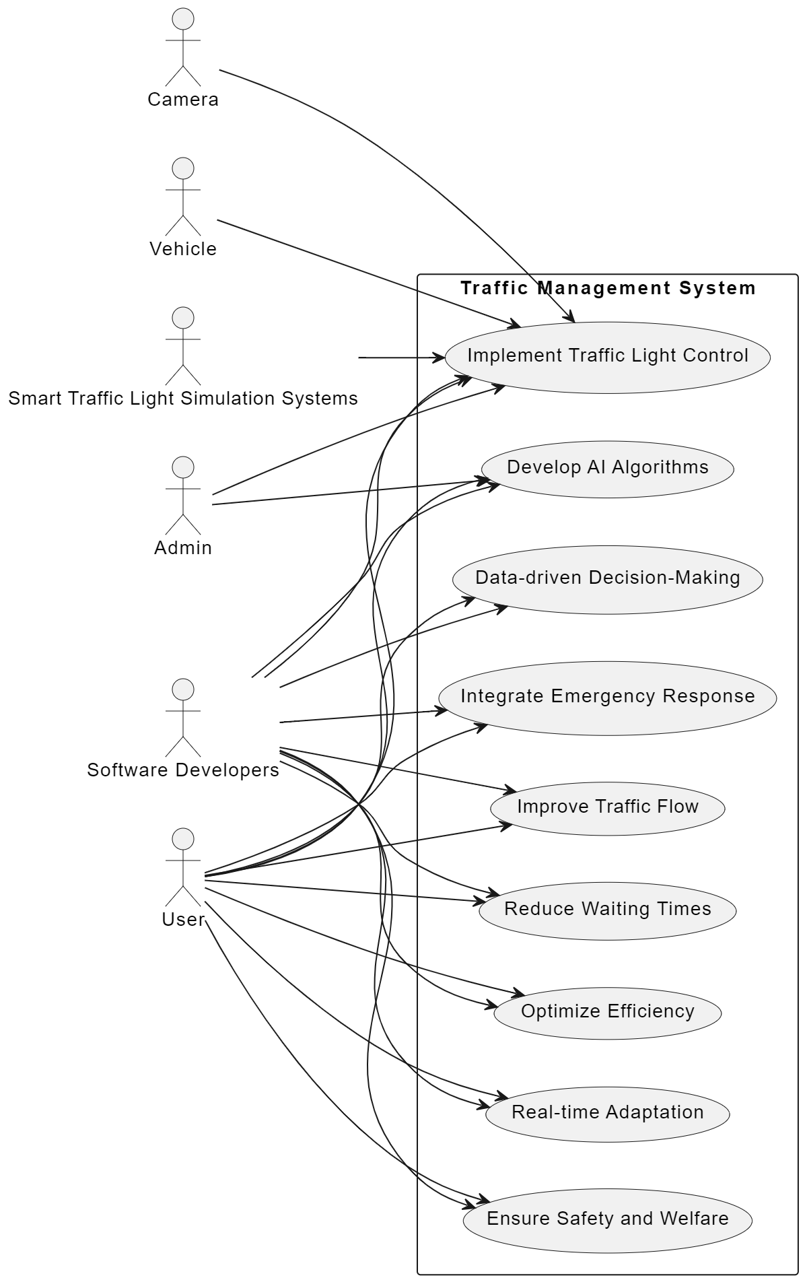

Sequence Diagram

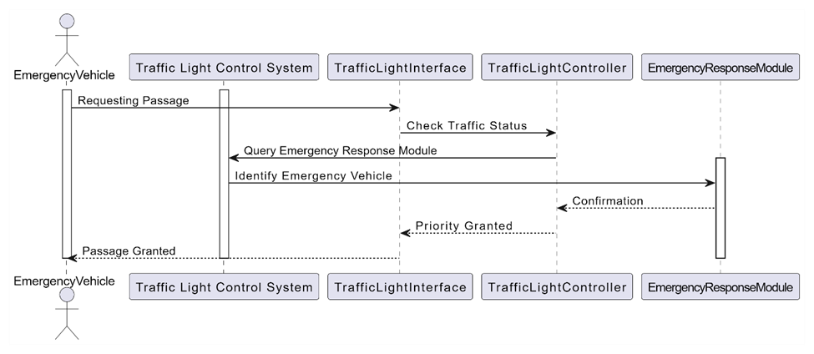

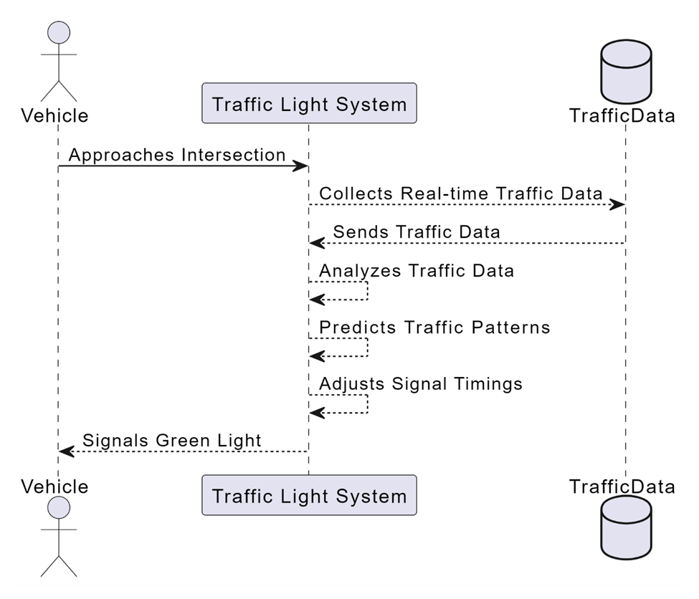

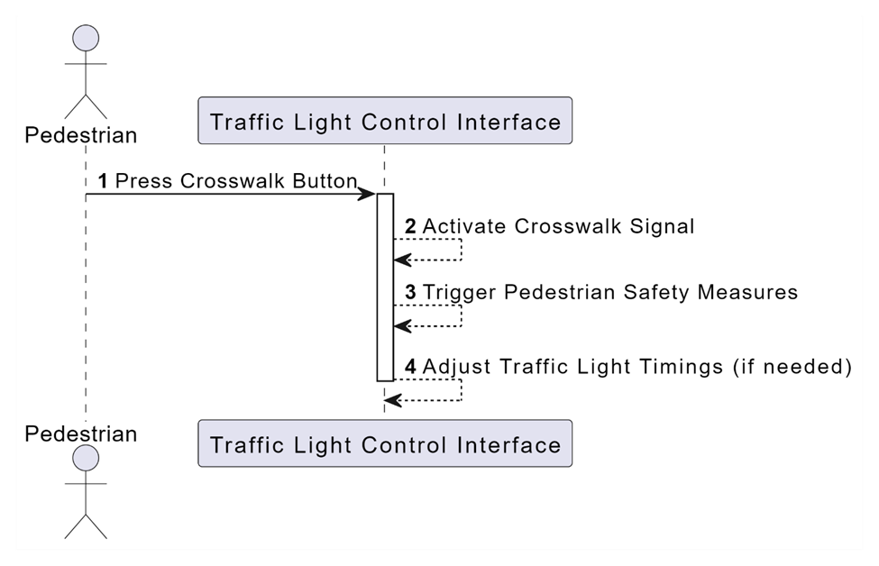

Activity Diagram

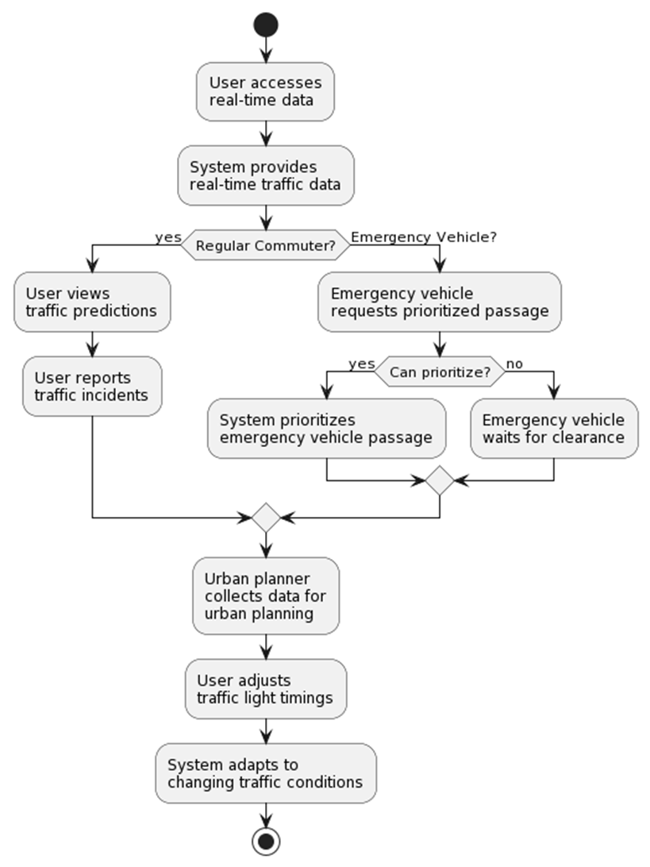

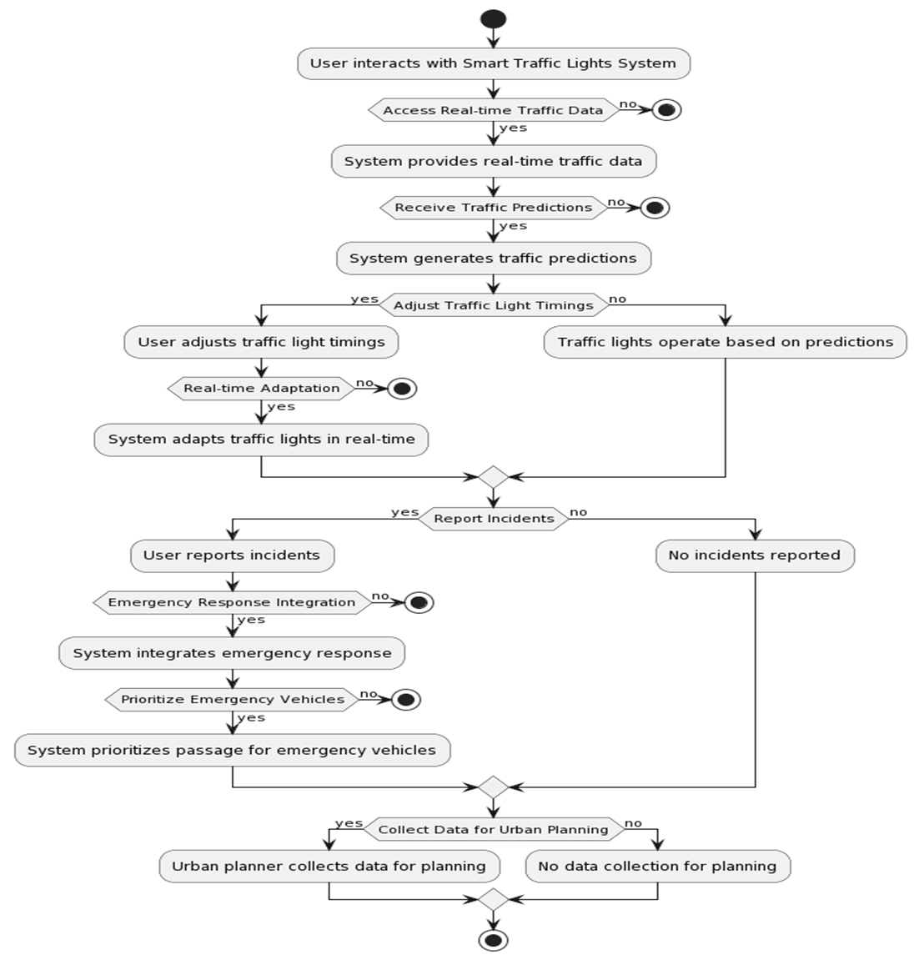

Component Diagram
- Traffic Light Control System
This is the main component that oversees the operation of traffic lights at the intersection.

- Vehicle Detectors
These are sensors deployed at various points in the lanes to detect the presence and movement of vehicles.

- Traffic Flow Data
This component represents the data collected about vehicle movement and density, which is used to optimize traffic light timings.

- Lanes
These represent the physical lanes at the intersection, each potentially having its own traffic light and vehicle detector.

- Pedestrian Flow Data
This component gathers data about pedestrian movement at the intersection, especially at crosswalks.

- Traffic Light Controller
This is a subsystem or a component that processes inputs from vehicle and pedestrian detectors to control the traffic lights.

- Communication Network
This facilitates communication between the detectors, the traffic light controller, and possibly a central traffic management system.

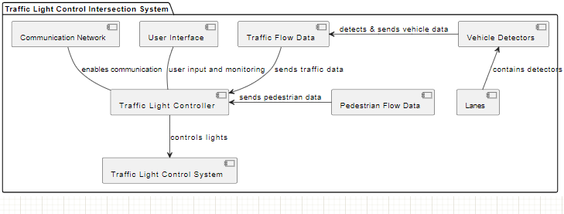

Class Diagram:
Traffic Light Control
Attributes:
controlID: String
currentStatus: String
timingSequence: Array
Methods:
changeLightSequence()
getCurrentStatus()
updateTiming()
Intersection
Attributes:
intersectionID: String
location: String
numberOfLanes: Integer
Methods:
getIntersectionStatus()
manageTraffic()
VehicleDetector
Attributes:
detectorID: String
type: String
detectionRange: Integer
Methods:
detectVehicles()
getVehicleCount()
TrafficFlowData
Attributes:
flowRate: Integer
averageSpeed: Float
vehicleCount: Integer
Methods:
calculateFlowRate()
updateFlowData()
Lane
Attributes:
laneID: String
laneType: String
capacity: Integer
Methods:
getLaneStatus()
setLaneType()
PedestrianFlowData
Attributes:
pedestrianCount: Integer
averageCrossingTime: Float
Methods:
calculateDensity()
updatePedestrianData()

Association: A TrafficLightControl system is associated with one or more Intersections. This means that each TrafficLightControl instance controls the traffic lights at one or more Intersections.
Multiplicity: One TrafficLightControl can be associated with multiple Intersections, and each Intersection is controlled by one TrafficLightControl.
Intersection and Lane:
Composition: An Intersection is composed of several Lanes. This implies that Lanes are part of an Intersection and cannot exist independently of it.
Multiplicity: An Intersection has multiple Lanes.
Intersection and VehicleDetector:

Aggregation: An Intersection has one or more VehicleDetectors. This is a whole-part relationship where VehicleDetectors can exist independently of an Intersection.
Multiplicity: An Intersection can have multiple VehicleDetectors.
VehicleDetector and TrafficFlowData:
Dependency: VehicleDetectors provide data to TrafficFlowData. TrafficFlowData depends on the input from VehicleDetectors to calculate traffic flow and other metrics.
Multiplicity: One VehicleDetector can contribute to one TrafficFlowData, but TrafficFlowData might receive inputs from multiple VehicleDetectors.
TrafficLightControl and TrafficFlowData:
Association: TrafficLightControl uses TrafficFlowData to make decisions about traffic light timings.
Multiplicity: One TrafficLightControl uses one TrafficFlowData, but TrafficFlowData can be used by multiple TrafficLightControl instances (if data is shared across multiple intersections).
Lane and PedestrianFlowData:
Dependency: PedestrianFlowData may depend on the characteristics of Lanes, especially in cases where pedestrian crossings are integrated within vehicular traffic lanes.
Multiplicity: One Lane may influence the PedestrianFlowData, and one PedestrianFlowData instance might be relevant to multiple Lanes.
TrafficLightControl and PedestrianFlowData:
Association: TrafficLightControl might also use PedestrianFlowData to manage pedestrian crossing lights and timings.
Multiplicity: One TrafficLightControl could use one PedestrianFlowData, and vice versa.

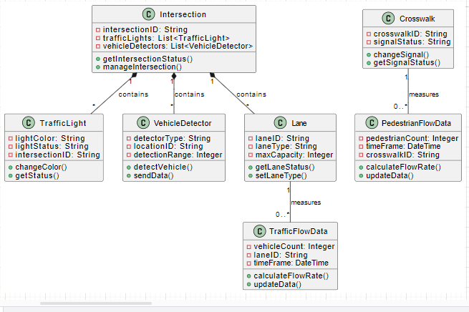

Data dictionary Diagram:
Traffic light controller

Attributes:
ControllerID (Primary Key)
Location
Status (Green, Yellow, Red)
TimerSettings
LastUpdateTime
Mode (Manual, Automatic)

Intersection:

Attributes:
IntersectionID (Primary Key)
Location
ConnectedControllers (List of ControllerIDs)
PrioritySettings
EmergencyMode
Vehicle Detector:

Attributes:
DetectorID (Primary Key)
Location
Status (Occupied, Unoccupied)
DetectionType (Magnetic, Infrared, Camera)

Traffic Flow Data:

Attributes:
FlowID (Primary Key)
IntersectionID
Timestamp
VehicleCount
Speed
LaneID

Lane:

Attributes:
LaneID (Primary Key)
LaneName
Direction
RoadType (Main, Side)

Pedestrian Detector:

Attributes:
PedestrianDetectorID (Primary Key)
Location
Status (Activated, Deactivated)
Traffic Light Controller - Intersection:

Each Traffic Light Controller is associated with one or more Intersections.
Foreign Key: IntersectionID in Traffic Light Controller.
Intersection - Vehicle Detector:

Each Intersection has multiple Vehicle Detectors.
Foreign Key: IntersectionID in Vehicle Detector.
Traffic Light Controller - Traffic Flow Data:

Each Traffic Light Controller generates Traffic Flow Data.
Foreign Key: ControllerID in Traffic Flow Data.
Vehicle Detector - Traffic Flow Data:

Each Vehicle Detector contributes to Traffic Flow Data.
Foreign Key: DetectorID in Traffic Flow Data.
Intersection - Lane:

Each Intersection has multiple Lanes.
Foreign Key: IntersectionID in Lane.
Traffic Flow Data - Lane:

Each Traffic Flow Data record is associated with a specific Lane.
Foreign Key: LaneID in Traffic Flow Data.
Pedestrian Detector - Pedestrian Flow Data:

Each Pedestrian Detector contributes to Pedestrian Flow Data.
Foreign Key: PedestrianDetectorID in Pedestrian Flow Data.

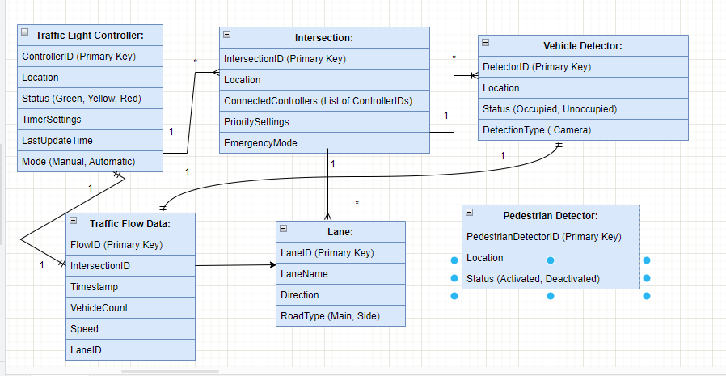

State Transition Diagram:
States:
Red: No vehicles or pedestrians are allowed to proceed in the controlled directions.
Green: Vehicles in one direction are allowed to proceed, including turning if permitted.
Yellow: Indicates the green phase is ending, warning vehicles to prepare to stop.
Pedestrian Walk: Allows pedestrians to cross; vehicles are stopped.
Emergency Mode: Overrides normal operation for emergency vehicles.
Transitions:
Red to Green: Occurs when the vehicle detector indicates a build-up of traffic in the respective direction, or on a timed interval if no vehicle data is available.
Green to Yellow: Triggered after a set duration of green light, which might be extended based on traffic flow data (e.g., if vehicles are still passing through).
Yellow to Red: Occurs after the yellow light has been on for a standard brief duration.
Any state to Emergency Mode: Triggered when an emergency vehicle is detected approaching the intersection.
Emergency Mode back to Standard Cycle (Red/Green/Yellow): Occurs when the emergency vehicle has cleared the intersection.
Pedestrian Request to Walk: If a pedestrian button is pressed, the system schedules a pedestrian walk phase, typically transitioning from Green to Pedestrian Walk.
Special Considerations:
Lane-Specific Variations: Some states may apply to specific lanes only (e.g., a turn lane may have a different state than through lanes).
Pedestrian Safety: The system must ensure all vehicle lights are red during the pedestrian walk phase.
Sensor Failures: The system should have a default safe state in case of sensor malfunctions.

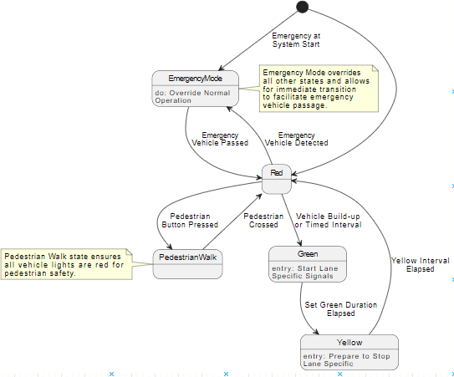

Database schema:
Traffic_Lights
Columns:
LightID (Primary Key)
IntersectionID (Foreign Key)
LightColor
LightStatus

Intersections
Columns:
IntersectionID (Primary Key)
Location
NumberOfLanes
Vehicle_Detectors
Columns:
DetectorID (Primary Key)
IntersectionID (Foreign Key)
DetectorType
LocationID
DetectionRange

Traffic_Flow_Data
Columns:
DataID (Primary Key)
VehicleCount
LaneID (Foreign Key)
TimeFrame

Lanes
Columns:
LaneID (Primary Key)
IntersectionID (Foreign Key)
LaneType
MaxCapacity

Pedestrian_Flow_Data
Columns:
DataID (Primary Key)
PedestrianCount
CrosswalkID (Foreign Key)
TimeFrame

Crosswalks

Columns:
CrosswalkID (Primary Key)
IntersectionID (Foreign Key)
SignalStatus
    - Traffic_Lights
LightID | Primary key
IntersectionID | Foreign key
LightColor

LightStatus

    - Intersections

IntersectionID | Primary key
Location

Number of Lanes

    - Vehicle_Detector
DetectorID | Primary key
IntersectionID | Foreign key
DetectorType

LocationID
DetectionRange

    - Traffic_Flow_Data:
DataID | Primary key
VehicleCount
LaneID | Foreign key
TimeFrame

    - Lane
LaneID | Primary key
IntersectionID | Foreign key
LaneType

Max capacity

    - Pedestrian_Flow_Data
DataID | Primary key
PedestrianCount
CrossWalkID | Foreign key
TimeFrame

Appendix A: Glossary
<Define all the terms necessary to properly interpret the SRS, including acronyms and abbreviations. You may wish to build a separate glossary that spans multiple projects or the entire organization, and just include terms specific to a single project in each SRS.>

Appendix C: To Be Determined List
<Collect a numbered list of the TBD (to be determined) references that remain in the SRS so they can be tracked to closure.>

